Acoustic suspended ceiling description

Range Lauder LINEA - Product reference 4.2.4

Patented system

Suspended ceiling lot

General
The suspended ceiling will be created using 4.2.4 panels product reference from the Lauder LINEA range of the Laudescher brand, which are compliant with standard EN 13964 Suspended ceilings.
The suspended ceiling will be installed in compliance with the manufacturer's recommendations
and installation good practice rules.
The service will include the supply and installation of the panels, with or without acoustic tiles,
the primary (if necessary), secondary grid system and all related services such as: erection of scaffolding, cutting operations, blockouts, offcuts and reveals, in accordance with the assembly drawings provided by the company.

Description of the acoustic ceiling
The acoustic ceiling will be of the following type:

Range: Lauder LINEA
Product reference: 4.2.4
Form: Linear
Total thickness: 55 mm
Slat section: 42 x 20 mm
Facing side: 42 mm
Slat thickness: 20 mm
Rear black wooden counter-slats: 34 x 45 mm
Spacing between slats: 43,71 mm
Average void area: 51%

Reaction to fire: B-s1,d0 / B-s2,d0 as defined in standard EN 13501-1

Solid wood:
- Pine
- Douglas Fir
- Oak

Finishing: (in accordance with building class)
- Natural
- Clear varnish
- Wax Color
- Wax Color MC

Wax Color or Wax Color MC finishing on Pine, with the following choice available to contractors: Honey, Oak, White, Wenge, Cherry, Chocolate, Mahogany, Grey.

- Edging system: edge D/A
- Modular dimensions: 1880 x 600 mm and 1265 x 600 mm

Acoustic recommendations
Any modification of recommended materials and the use of materials not covered by an acoustic test report (French or European) specifying their acoustic characteristics will be subject to the prior written agreement of the contractor. Extracts of commercial documents cannot under any circumstances be used to replace acoustic test reports.

Acoustic performance will be achieved by adding mineral or stone wool tiles measuring 595 x 595 mm and 20/22 mm thick. They will have a minimum density of 100 Kg/m³.
They will be faced with black fleece. Tests will be conducted in compliance with standards EN ISO 354 and EN ISO 11654 on a plenum of 250 mm.
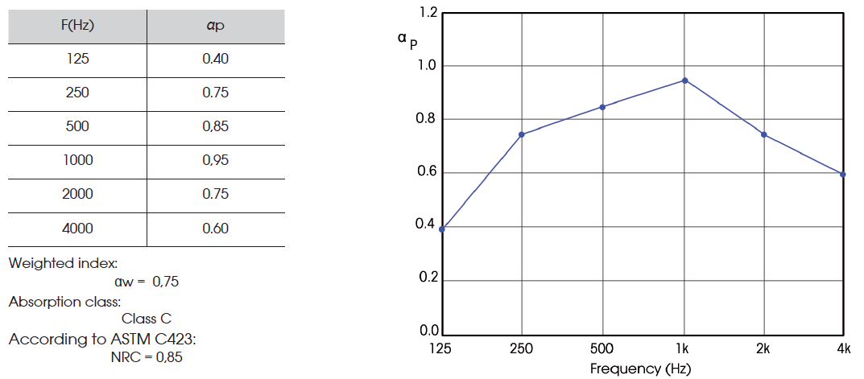

Fire recommendations
The product must be supplied with a test report performed on the finished product, in acoustic or open version, in an approved laboratory in accordance with standard EN 13501-1.

Reaction to fire: B-s1,d0 / B-s2,d0 as defined in standard EN 13501-1

- Technical performance
- The product must have a VOC classification in accordance with EN ISO 16000-3, 6, 9 and 11
in compliance with current legislation
- PEFC / FSC: the product must be supplied with a certificate and individual number
- Humidity resistance: in accordance with building class
- Maintenance: Keep free of dust. Lauder LINEA panels must not be cleaned with detergents or water-based products under any circumstances.
- Storage: Products in the Lauder LINEA range must be stored flat, in premises with constant indoor humidity sheltered from water and blown air heating. Products in the Lauder LINEA range must be stabilised in the destination premises for at least 48 hrs prior to installation.

- Installation
- The ceiling will be installed on a grid of T24 main runners with black capping (type DONN DX24 or equivalent), concealed by a patented system, compliant with current standards
and good practice rules in each country.
The T24 main runners will be fixed at a distance of 600 mm, "D1".
The main runner components will be suspended by Ø6 mm threaded rods hung at maximum distance "P" of 1200 mm in a staggered configuration. The distance between the main runners will be maintained by a minimum of 1 cross bar per panel. The cross bars must be positioned at a maximum distance of 200 mm from the wall. The finishing edge is created using a matt black perimeter trim to provide a shadow line along the wall.
The system gives the panels a perfectly flowing and seamless appearance.

